**GENERAL R TIPS:**

* quickly run lines of code by selecting a line or lines of interest and pressing (CTRL+ENTER)
* make sure you're typing in the lower box if you're responding to prompts (ex: Y/N?)
* if nothing shows up in the lower box, check to see if you accidentally typed in the top box, delete the added text and continue below
* if you accidentally delete a line of code, press (CTRL+Z)
  + if that doesn't restore the code, close without saving and re-open the R file
  + in the case that you accidentally save, re-copy the master R script and open/continue with the copy
* to use a line of code you just ran, use the arrow keys while typing in the lower box to navigate to previously used lines of code

**ALWAYS run these lines of script when first opening R**



**LOAD SAVED PROJECT**

*file -> open file -> navigate to project folder -> output -> R_data -> load RDATA File*

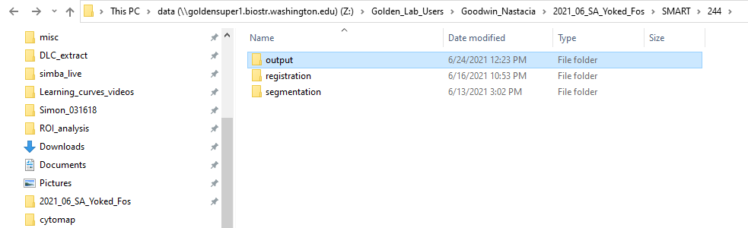

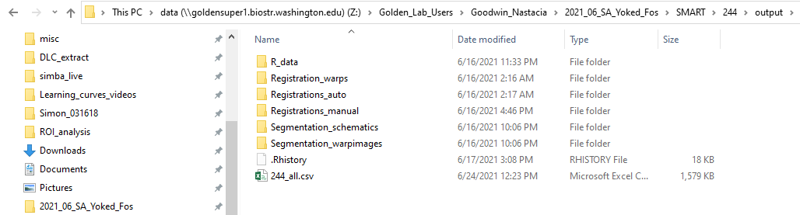

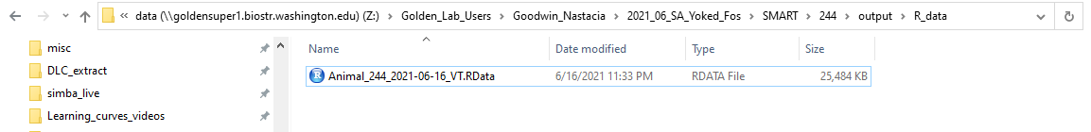

**STEP 1: PROJECT SET-UP:** tell SMART where your images to analyze are and where it should put project output (do this for each new slice or brain you're analyzing!)

**MAKING A NEW PROJECT**

1. start by creating a folder for the brain you're working on
2. create 3 subfolders: **output, registration, segmentation** (this folder setup may vary depending on who you're analyzing brains for!)
   1. the **output** folder is where SMART’s project output will be stored (check back here once you’ve finished the process to see registered brain images and images post-segmentation
   2. the **registration** folder is where you should place raw images
   3. the **segmentation** folder is where you should place exported QuPath segmentation results (these images should look like a collection of bright dots—no brain slice images here!)

*an example project folder setup:*

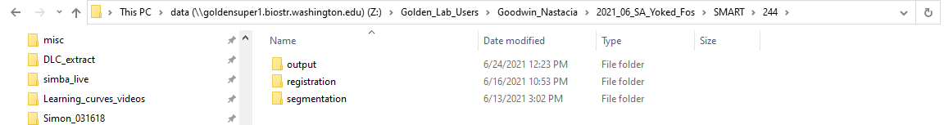

1. run the following lines of code one at a time and respond to the prompts for each accordingly

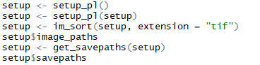

1. quickly copy file paths by navigating to folder in file explorer, clicking in top navigational bar, selecting all and copy-pasting into R

*for example, (CTRL+C), (CTRL+V) this selection when prompted for path to registration folder*

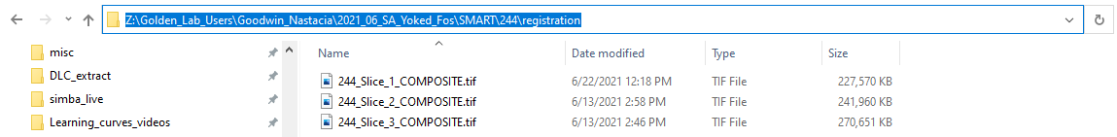

**FINDING ATLAS PLATE NUMBER**

1. open **SMART_alignment_reference_atlas.pdf** (find in "*Z:\Protocols\SMART\SMART_alignment_reference_atlas.pdf*")

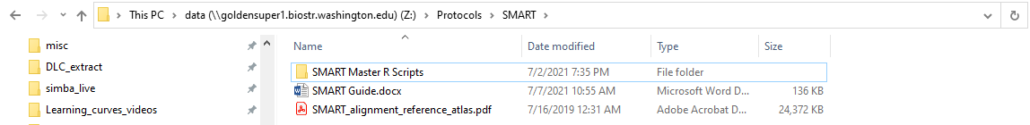

1. search the atlas to find the plate that best matches your brain slice: try to match major landmarks!

*here is the corpus callosum. does its alignment match the atlas plate?*

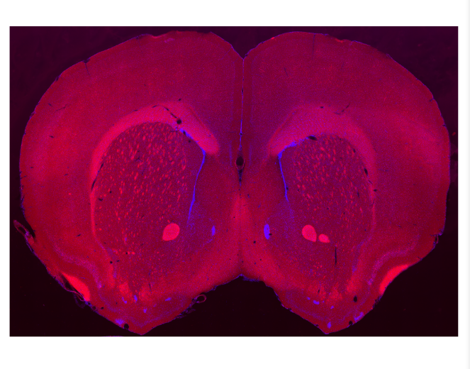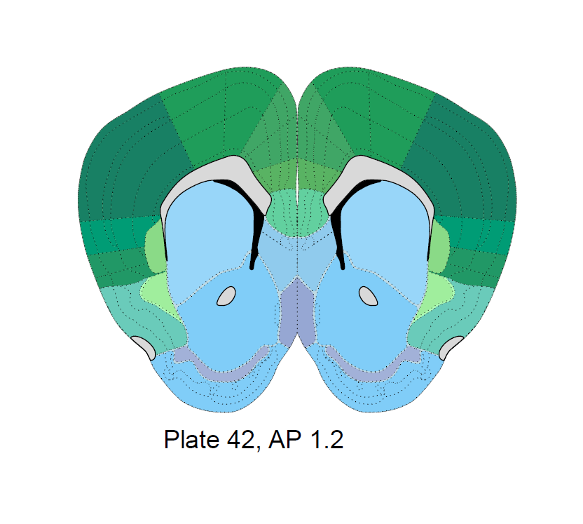

**TIPS:**

**z image number** refers to the number of images in a project (your first image is 1, your second image is 2, etc.)

if you get a savepath error at any point, re-run project set-up, return to where you encountered the error, and try to re-run code

**SAVING YOUR PROGRESS:** run this code! make sure to repeat this throughout



**STEP 2: REGISTRATION:** matches our brain atlas to our slice image so SMART knows which regions of the brain are where in our image

**CREATING A FILTER FOR REGISTRATION**

1. run the **default filter**

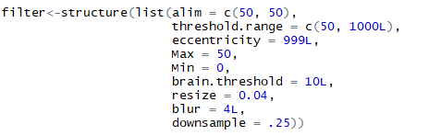

1. run the **registration filter GUI** to check and modify filter settings



**REGISTRATION FILTER GUI:** *we want the green outline to match the outline of our brain slice*

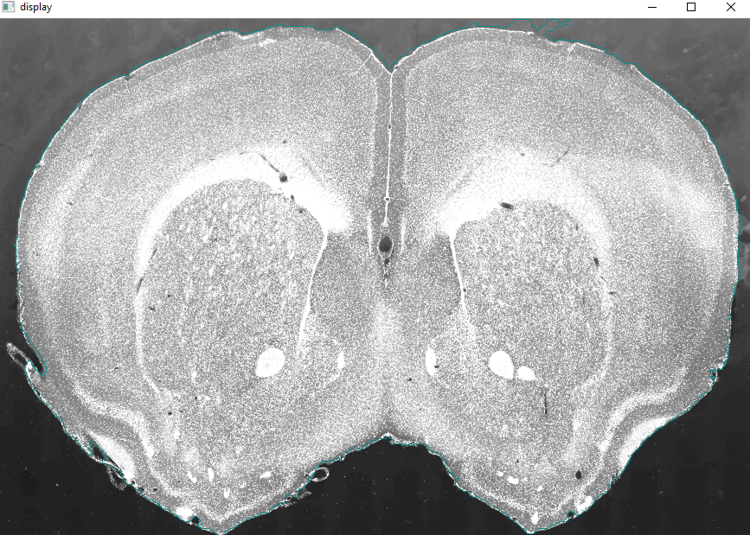

**TIPS:**

change **Max** and **Min** to adjust image exposure (**increasing Min** will make image **darker** and **decreasing Max** will make image **brighter**)

change **brain threshold** to change how large or small green outline is

change **blur** to smooth edges of green outline

for ease of exiting GUI, click an opened GUI window then hit ESC

**AUTO-REGISTRATION**



**TIPS:**

**always run pre-autoregistration before re-running auto-registration**



if auto-registration has matrix error, re-run filter and change **resize**

if auto-registration has transformation error, look at original image to see if the slice is close to the image borders

* to fix this, open original image in **ImageJ**

*imagej -> image -> adjust -> canvas size -> increase height and width values by ~100 pixels*

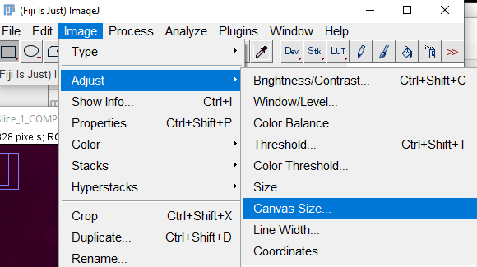 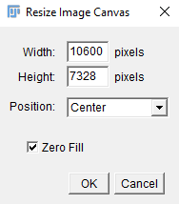

if there are any abnormally bright areas, select with selection tools and fill using *edit -> fill*

**when saving, keep the same file name and file location as the original image**

*file -> save as -> TIFF*

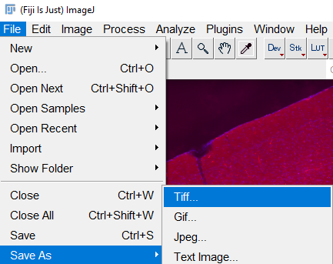

repeat this process with the same **new** dimensions you used for the **segmentation image file** to ensure image sizes match up during SMART processing

**MANUAL REGISTRATION**

1. open **pre-registration script.R** (find in *"Z:\Protocols\SMART\SMART Master R Scripts\pre-registration script.R"*)
2. select and run all of pre-registration script.R

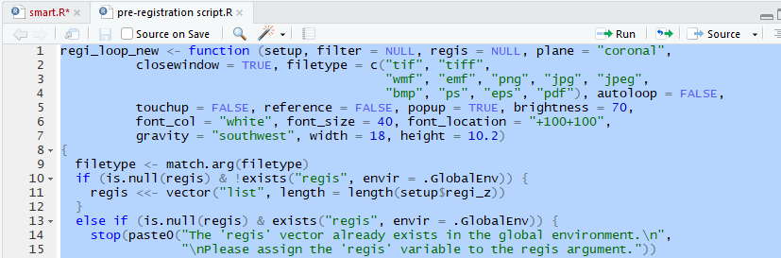

1. run **manual registration**



**TIPS:**

when prompted for **plate number**, use your atlas plate number! (corresponds to AP coordinate)

to find plate number, navigate to your SMART project folder *-> output -> Registrations_auto*

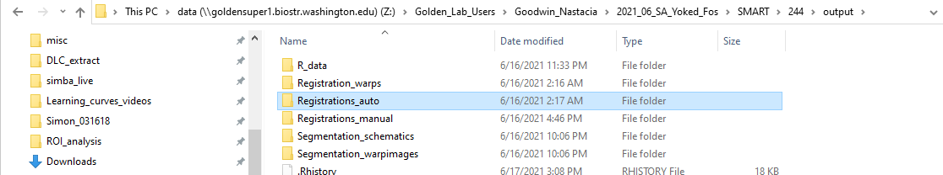

auto-registered images have file names in the format *"registration_z_1_plate_42_AP_1.2"*

*the number after “plate” is your atlas plate number!*

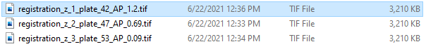

**MANUAL REGISTRATION GUI:** *we want the purple outline to line up with our slice!*

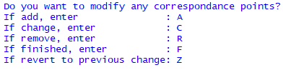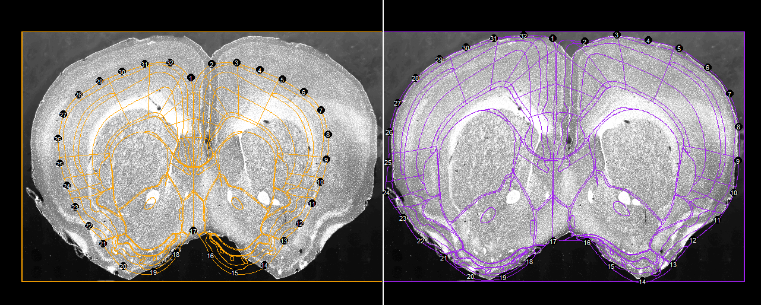

*when adding points click the desired position of your point on the slice in the right image first, then click the corresponding place on the orange outline on the left*

**TIPS:**

align the midline first! this usually involves changing the positions of points 1 and 17

if registration is very messy, deleting all points other than the midline can be helpful

* **r** for remove, then list many points shorthand using a colon
  + for example, if I have 32 points, I remove all but 1 and 17 using **2:16, 18:32**

if adding points, stick to a max of 4 at a time before you get more comfortable placing them!

if you mess up positioning a point, finish adding the rest of the points, then use **z** to revert to your previous adjustments

if there are gaps/tears in the slice tissue, ensure outline traces around them (pretend the slice is perfect)

look for landmarks to help with alignment! familiarize yourself with the identification and alignment of several distinct regions in your slice from [here](https://mouse.brain-map.org/experiment/thumbnails/100048576?image_type=atlas)

if the image is hard to see, try to adjust **registration filter settings** and re-run script (alternatively open the original image file and use that as a positioning reference)

if the atlas outline does not move when new points are added/old points are adjusted, try deleting points that may be pinning the outline in the wrong conformation (**continuing to add more points will not help!)**

to save in the middle of a manual registration hit **f** and then **y** to **save** (you can always reopen the project and continue later!)

**STEP 3:** **SEGMENTATION:** takes cell annotation outputs from QuPath and counts how many cells there are per atlas brain region

**CREATING A FILTER FOR SEGMENTATION**

1. run **default segmentation filter**

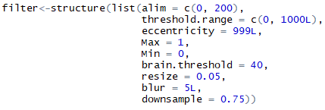

1. run the **segmentation filter GUI** to check and modify filter settings



**SEGMENTATION FILTER GUI:** *we want all the dots to be marked in red!*

*these cells have all been recognized by the filter!*

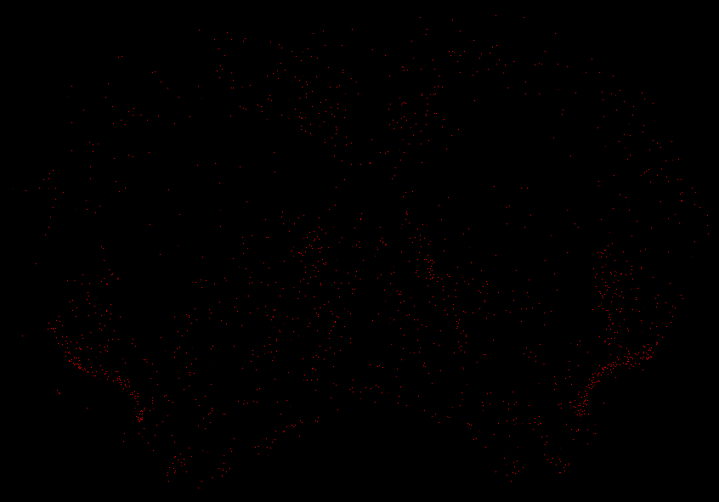 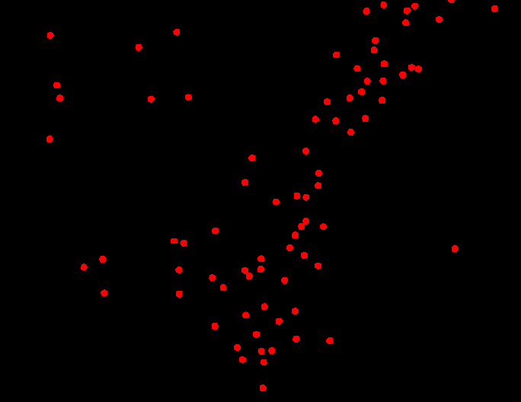

**TIPS:**

click within segmentation image to zoom in on a particular region

* increase **downsample** and re-run filter to increase size of zoomed-in region

**alim** changes the range of cell body sizes the filter looks for (if filter is missing larger cells, increase max **alim**, if filter is counting two cells as 1, decrease max **alim**)

* to catch more cells after changing **alim**, change **downsample**

for ease of exiting GUI, click an opened GUI window then hit ESC

**SEGMENTATION**



1. check number of segmented cells against your QuPath segmentation counts, if this doesn’t match, change **segmentation filter settings** and re-run segmentation

*segmentation may not catch all your segmented cells! being off by ~100 cells or fewer is normal, but always check with your grad student to ensure that the cell count is close to the QuPath output*

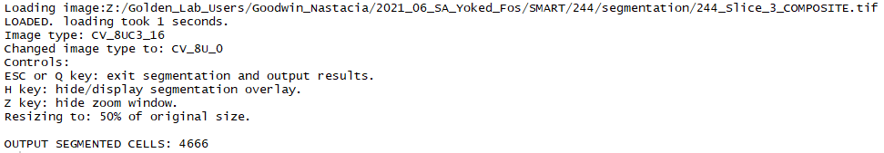

if you see the error *wholebrain::segment(setup$image_paths[[c]][z], filter = filter)* re-run code for **PROJECT SET-UP** to restore image savepaths, then try to run segmentation again

1. run **forward warp**

*this transforms segmented cell counts back onto the Allen Brain Atlas space and is essential for the standardization and analysis of your data*



**STEP 3:** **DATA COLLECTION:** viewing and saving the results of segmentation for analysis

1. to export cell counts by region as a .csv file, first run **get table**



1. run **write.csv** after copying and pasting the path to your destination folder and file name into “*file path here”*

make sure format is *“Z:/Filepath/Filename.csv”!*



to save positional data of all segmented cells, replace *"table"* in **write.csv** with *"dataset"*

**STEP 4:** FIGURES: run any of these lines of code to see some cool figures!

*run* ***plot*** *to view figure of cell counts by brain region and hemisphere*



*run* ***rois*** *to get dataset of just regions of interest*



*run* ***sunburst plot*** *to view data in the format of a sunburst plot*

**

*run* ***glassbrain*** *to view cells in their 3D position in the whole brain*

**

feel free to try additional scripts from the documentation as well :) not all of them are on here!

to learn more, check the [SMART documentation](https://github.com/sgoldenlab/SMART/blob/master/docs/tutorial.md)